

Employer’s
Pupil Work Placements
and
PVG Requirements



Key Message
Most pupils undertaking work placements do NOT require PVG Scheme membership. PVG membership is only required in limited circumstances where a pupil aged 16 or over is undertaking a regulated role involving children and/or protected adults.

When is PVG Membership Required?
A pupil will only require PVG Scheme membership if all four of the following apply:
- They are 16 years old or over
- They have *contact with children and/or protected adults
- They are leading one of the regulated activities
- The activity and contact are a necessary part of their role on placement
*Contact: with children or protected adults means physical contact, verbal, written or visual communication. It also means exerting power and influence over the child or protected adult.
If any one of these conditions are not met, PVG membership is not required.

Advice for Employers

Employers and Employees Supervising Pupils
Employers do not need a PVG check for their own staff simply because they:
- Supervise a pupil on placement
- Have contact with a pupil on placement
Appropriate safeguarding and supervision arrangements should still be in place.

Importance of Supervision

Young people should be appropriately supervised during placements in line with Health and Safety Executive guidance.
Supervision often means that PVG membership is not required, particularly where pupils are:
- In schools
- Nurseries
- Hospitals
- Care homes
- Other settings involving vulnerable groups
but are not independently responsible for children or protected adults.

Employees Supervising Pupils
Employers do not need a PVG check for their own staff simply because they:
- Supervise a pupil on placement
- Have contact with a pupil on placement
Appropriate safeguarding and supervision arrangements should still be in place.

Decision Tree
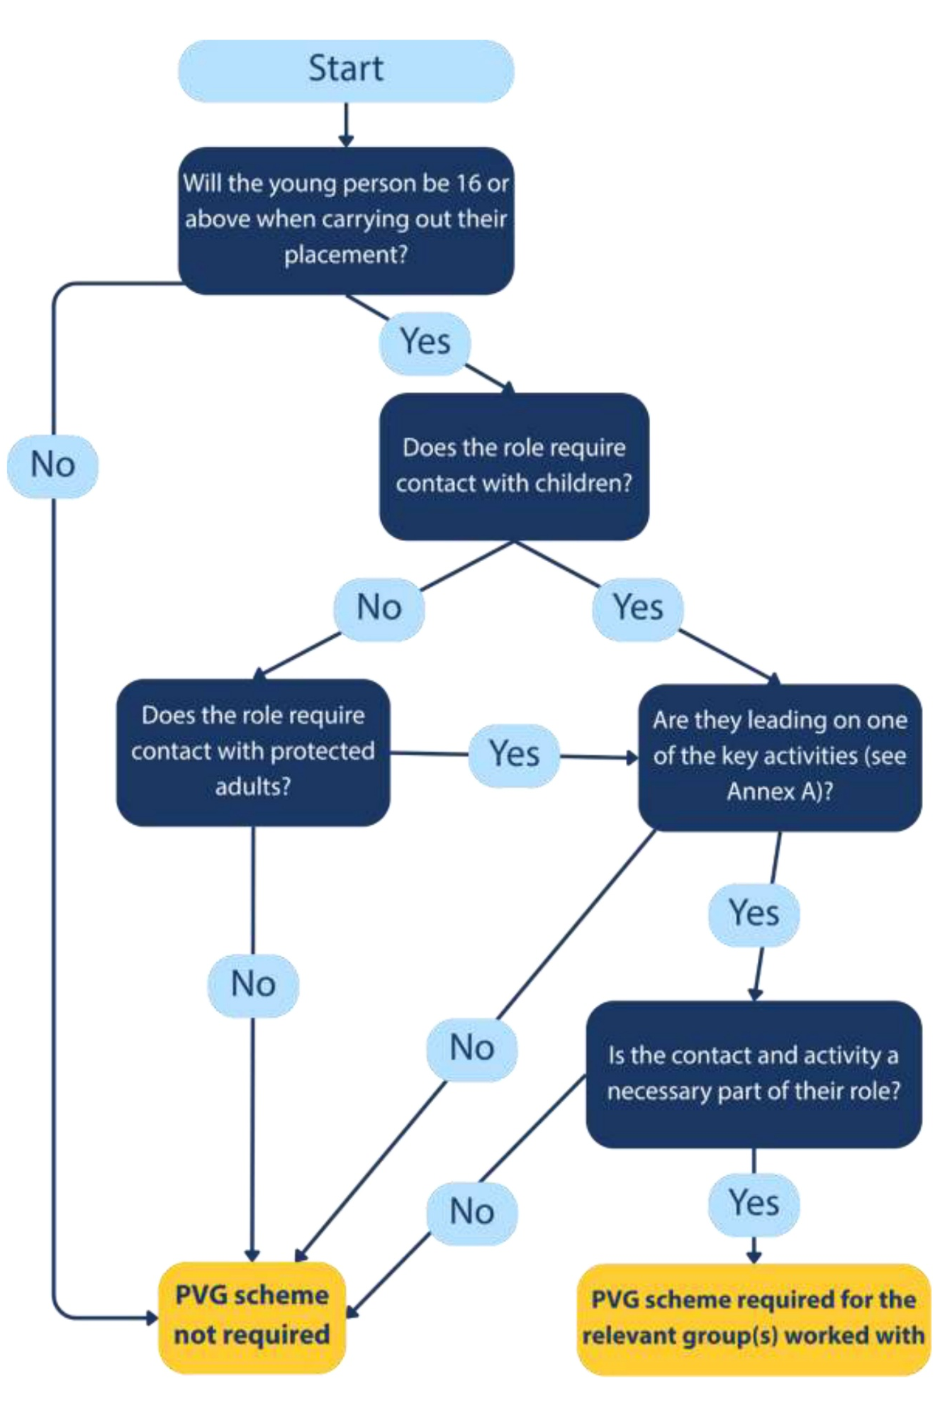

Quick Summary

PVG NOT Usually Required When:
✅ Pupil is under 16
✅ Pupil is supervised
✅ Pupil is assisting rather than leading activities
✅ Pupil has contact with children but is not responsible for them
✅ Employer is attending careers events, talks or DYW activities
✅ Employer staff are only supervising pupils on placement.

PVG May Be Required When:
⚠️ Pupil is 16+
⚠️ Pupil is leading teaching, coaching or activities
⚠️ Pupil is responsible for care of children or protected adults
⚠️ Pupil has necessary unsupervised contact with vulnerable groups
⚠️ Employer staff have necessary unsupervised contact with pupils in schools or colleges as part of their role.

 | PVG NOT usually required | PVG MAY be required
Pupil is under 16 | R
Pupil is supervised | R
Pupil is assisting rather than leading activities | R
Pupil has contact with children but is not responsible for them | R
Employer is attending careers events, talks or DYW activities | R
Employer staff are only supervising pupils on placement | R
Pupil is 16+ |  | S
Pupil is leading teaching, coaching or activities |  | S
Pupil is responsible for care of children or protected adults |  | S
Pupil has necessary unsupervised contact with vulnerable groups |  | S
Employer staff have necessary unsupervised contact with pupils in schools or colleges as part of their role |  | S

Bottom line: For the vast majority of school work placements and DYW activities, neither the pupil nor the participating employer will require a PVG check. The key tests are age (16+), responsibility, leadership of activities, and unsupervised contact with children or protected adults.

